UNIVERSITY FOR DEVELOPMENT STUDIES

FACULTY OF MATHEMATICAL SCIENCES

DEPARTMENT OF COMPUTER SCIENCE

A PROJECT REPORT ON:

CAMPUS HOSTEL MANAGEMENT SYSTEM

Submitted by*:* BASSELL DARI IDDISAH

ID: DFMS/0058/18

DATE: JULY,2020

PROGRAM: DIPLOMA IN COMPUTER SCIENCE

SUPERVISOR: DR. ABDUL MUMIN

# ACKNOWLEDGEMENT

I am sincerely obliged to many worthy persons, without whom I could have never had the opportunity of learning greatly with interest. These influential dearest of human beings have made my tertiary stay on campus lively day and night until really my engagement with my research has wholly come to its end. Again, my work without their help is a work incomplete. Still I am truly indebted and thankful to:First and foremost, All-Mighty Allah, who has taken care of me to reach this level of education, my supervisor, Dr. Abdul Mumin, whose guidance has been present. Being also the best and kindest of all persons and

# DECLARATION

I hereby declare that the ideas and points that make up this write up are totally mine and no author’s.Except for those which have been referenced from sources.

# DEDICATION

# This research paper is dedicated to my fellow students, who have helped me in the acquiring of some very helpful information as to why students select the hostels that they do, how students search for hostel, and why students decide to change their hostels.

# ABSTRACT

The aim of this study was to investigate the issue of students making the right choice when it comes to hostel selection and willingness to incorporate technologies, such as web development into everyday practice. This research was considered important as numerous studies on the benefits of using these technologies have been documented, yet despite this not many students have incorporated them into their practice. The data collected was analysed and the emerging themes were examined in line with the research aims. Results from the study indicate that many students only select hostels on the basis of just the core (“Availability of light and water, Distance from the campus and amount of money to be paid per room”). Resistance towards the incorporation of the technologies is present. The main causes of resistance appear to be related towards a number of concerns or reservations of students held by hostel landlords and caretakers. Among these were the need for information on the noise level of the surrounding environment, how safe it is to walk at night and how the landlord or caretaker keeps the place from destruction. Despite some of the resistance present, students seem to perceive the technologies as useful in locating hostels that go hand in hand with their preferences and would otherwise stay empty until the end of the academic year.Students stated that they were generally open to receiving further education and training on these technologies.

Table of Contents

ACKNOWLEDGEMENT i

DECLARATION ii

DEDICATION iii

This research paper is dedicated to my fellow students, who have helped me in the acquiring of some very helpful information as to why students select the hostels that they do, how students search for hostel, and why students decide to change their hostels. iii

ABSTRACT iv

CHAPTER ONE 1

1.0 INTRODUCTION 1

1.1 Background of the Study 1

1.2 PROBLEM STATEMENT 2

PROJECT QUESTIONS 3

1.4 OBJECTIVE OF THE PROJECT 3

1.5 SIGNIFICANCE OF THE STUDY 3

1.6 STRUCTURE OF THE PROJECT 4

CHAPTER TWO 6

LITRETURE REVIEW 6

3.1 INTRODUCTION 6

3.2 MANAGEMENT SYSTEMS 6

3.3 SYSTEM 6

3.4 PORTAL 7

3.5 MICRO-FRAMEWORK 7

CHAPTER THREE 8

3.1 METHODOLOGIES 8

3.1.1 DATA FLOW DIAGRAM 9

3.1.2 USE CASE DIAGRAM FOR USERS AND ADMIN 10

3.1.3 INPUT AND OUTPUT DESIGN 11

CHAPTER FOUR 16

4.0 RESULTS AND DISCUSSIONS 16

4.1 LIMITATIONS O F THE STUDY 17

4.2 SUMMARY 17

4.3 RECOMMENDATIONS 18

CHAPTTER FIVE 18

4.5 CONCLUSION 18

REFERENCE 19

# CHAPTER ONE

# 1.0 INTRODUCTION

## 1.1 Background of the Study

Everyone needs a place to lay his/her head to rest and let go of the stress gained in the day or prepare for the activities of the next day. So much so that schools have hostels and dormitories where students get a goo night sleep. But is it actually a good night sleep of the students don’t feel comfortable or even safe at the place where they lay their head? This is the reason there must be a system in place that can combat this issue, and since this is the twenty-first century, why not let it be an electronic system.

Hostel management system is an online web base application that helps students to find and analyse all available hostels on campus in order to find a hostel that best fits their specifications. As should be used in a hostel management system, this project captures the very features that gives it the name “Hostel Management System”. A system which gives students the power to register hostels into a database, categorize all registered hostels during hostel registration, update information about the hostels, delete hostel from the database, contact hostel landlords or caretakers and give comments on the hostel. Students may use this system to find the best available hostel the have their preferred layout, environmental noise level, room size and much more.Students and non students can use this app on their phones, laptop computers, desktop computers, and any other web supporting smart device.

A hostel management system ensures that individuals are able to compare hostels on campus in order to make the right choice when coming to campus for either the first time or even the last time, book a hostel on campus right at the comfort of his/her home without having to chase his friends and classmates around in order to seek information about a particular hostel or even worse, leave the comfort of his home and spend precious time, money and other resources to inspect each hostel he considers. This project is built for managing and computerizing hostels on campus , giving students the ability to book, make hostel reservations for a room that they may prefer and keep track of current hostel news updates that will be posted by the students themselves. It maintains hostel details, hostel conditions, environmental conditions of the hostels and the general image that the name of that hostels portray.Unlike the already occurring method of finding hostel which takes a lot of time and can cause some issues for the one looking for the hostel and the one being asked about the hostel. Due to this, people who don’t want to be seen as a menace go through the trouble of moving from hostel to hostel in order to get details about the hostels and while at it, almost always forget to ask some very important questions like, “How noisy is the place”. For one, we look for the most comfortable hostels that fit our budget not taking into consideration that the comfort that we imagine the hostel to be have a lot more factors than just “How big the room is, If it has internal washroom and if the wall sockets function properly”.To solve the above problems and many other issues that is not thought of when selecting a hostel, this project is built for managing and computerizing the method by which we choose a hostel to spend the rest of the academic year in, However, the benefit of a comprehensive hostel management system for general use are hard to qualify, as the main target for hostel management is an improved service quality. In monetary aspects, hostel management systems can reduce costs made by individuals looking for a place to book as they do not have the need to spend money in order to travel long distances just to learn about a few other hostels in their vicinity.

## 1.2 PROBLEM STATEMENT

Prior to the development of an online Hostel Management System, hostel selection has always been a practice that has got more and more people regretting the decisions they made by choosing a specific hostel. Based on these reasons, there resulted the inadequate maintenance system which involve an improper handling of hostel amenities by caretakers.

Active recollection of all hostels known by an individuals may cause forgetfulness of some important information. The level of security for the individual is not guaranteed because the information gotten from an individual about a hostel might not be accurate or may even be confused with information about another hostel. Thereby if this information comes from the wrong person, there is still a risk selecting a hostel that goes against all or most of an individual’s preferences.

## PROJECT QUESTIONS

How do people benefit from hostel management?

## 1.4 OBJECTIVE OF THE PROJECT

The objectives of the project is to develop a web application that relays information about hostels near and far from the school campus. This system should also allow users to leave comments about hostels, post the latest news update of the hostels and even contact the hostel caretakers in case there is interest.

Admin user privileges in creating, updating and deleting hostels from the database.

## 1.5 SIGNIFICANCE OF THE STUDY

The significance of the study is to;

1. Realise how important it is for people to adapt to the modern world by using electronic systems and platforms to easy their daily activity and provide an avenue for productive practices.

2.Give access of hostel information to individuals to check availability of all hostels in the vicinity of the campus and to also know when an unavailable hostel becomes available..

4.Improve working condition and help to build secure system

## 1.6 STRUCTURE OF THE PROJECT

The purpose of this project document is to give an overview of major phases involved throughout the development of this project. Basically, the research is divided into four chapters.

Chapter one entails the introduction of the research, this chapter covers the overview of the project including the problem statement, Research, Objectives of the study, External objectives, Specific objectives, significance of the study as well as the structure of the study.

Chapter two entails the literature review. Which briefly talks about the issues concerning the development of an online hostel management system. As well as sufficient background knowledge based on relevant literature reviews of related works and thoughts with respect to the advancement of this project. An introduction of the literature review and review of the preview chapter. This chapter begins with the introduction of hostel management system, understanding the online selection of hostels, As well as understanding the role of management systems. And also, the introduction of the literature review which talks about the development of online hostel management system as well as issues concerning the development of an online hostel management system, as well as the review of the previews chapter.

Chapter three talks about the methodology which emphasises on the stages and phases which the project underwent before the system was developed. The use of diagrams and pictures of the various sections of the project was also included in this chapter. Also, the output of the project was also briefly discussed in this chapter. How the system is going to look like. How it is going to be used as well as the impact it will bring on the users and the administrators.

Chapter four being the final chapter, talks about conclusion of the project which talks about the details of a customer who selected a hostel as well as the advantages or the impact of the system. Recommendations of the system is also entail in this chapter. The system is recommended to educational institutions whose accommodation are poor. It can also benefit admins and students who are in the system by simply logging in to make a hostel selection.

# CHAPTER TWO

# LITRETURE REVIEW

## INTRODUCTION

The main purpose of this chapter is to review the development of hostel management system. This chapter will look into issues concerning the development of an online Hostel Management System. This chapter defines facts and finding on hostel management after reading some articles and online posts that are related to the research work.

## MANAGEMENT SYSTEMS

In its most basic sense, a management system is how organizations ensure things get done. If your organization holds regular staff meetings, those are part of its management system. If you have reminders to yourself on post-it notes strewn about your desk, those are part of your management system. Taken as a whole, all of the processes, formal and informal, that enable your organization to deliver its products or services, make up its management system. (<https://onstrategyhq.com/resources/what-is-a-management-system/>)

## SYSTEM

A **system** is a group of interacting or interrelated entities that form a unified whole. A system is described by its spatial and temporal boundaries, surrounded and influenced by its environment, described by its structure and purpose and expressed in its functioning.

(<https://en.wikipedia.org/wiki/System>)

## PORTAL

A portal is an idea of a website or service that offers a broad range of services, such as e-mail, games, quotes, search, news, and stocks. A portal, web portal, or vortex site offers such a broad range of commonly accessed services that visitors are more likely to visit more often. For example, the [Yahoo](https://www.computerhope.com/jargon/y/yahoo.htm) homepage is a portal that gives visitors access to all the places and news that are most popular(Computer Hope, 2020).

For this research, the type of portal that will be used for an online Hostel Management System will be horizontal or functional portal where it has the characteristics of a range of services; search engines, directories, information management.

## MICRO-FRAMEWORK

A **micro-framework** is a term used to refer to minimalistic web application framework. It is contrasted with full-stack frameworks.

It lacks most of the functionality which is common to expect in a full-fledged web application framework, such as:

* [Accounts](https://en.wikipedia.org/wiki/User_account" \o "User account), authentication, authorization, roles
* Database abstraction via an [object-relational mapping](https://en.wikipedia.org/wiki/Object-relational_mapping" \o "Object-relational mapping)
* Input validation and input sanitation
* [Web template](https://en.wikipedia.org/wiki/Web_template" \o "Web template) engine

Typically, a micro-framework facilitates receiving an [HTTP request](https://en.wikipedia.org/wiki/HTTP_request" \o "HTTP request), routing the HTTP request to the appropriate controller, dispatching the controller, and returning an HTTP response. Micro-frameworks are often specifically designed for building the APIs for another service or application. For example, Lumen micro-framework is designed for Micro-services development and API development.

(<https://en.wikipedia.org/wiki/Microframework>)

# CHAPTER THREE

## 3.1 METHODOLOGIES

For any project to be completed, it has to go through stages called Development Life Cycles. System Development Life Cycles(SDLC) is the process of understanding how information system can support business needs, designing the system, building it and delivering it to the users. The SDLC composes of four phases: Planning Analysis, Design and Implementation.

In order for this project to be developed, The methodology that will be used is the system structured analysis and design methodology. The SSDAM is classified as Waterfall Development. With waterfall Development. Analyst and users proceed sequentially from one phase to the other and each phase can be mapped out and evaluated(Henver, 2004). Below in figure 3,1 is a diagram on waterfall methodology.

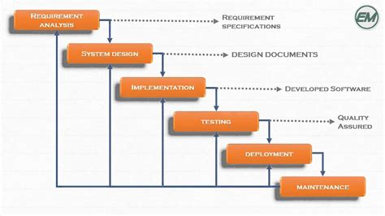

### 3.1.1 DATA FLOW DIAGRAM

A data flow diagram is a graphical representation of the flow of data through an information system, modelling its process aspect. A DFD shows what kind of information will be put to and output from the system, where the data come from and go to, and where the data will be stored.

The development of DFD’S is done in several levels. Each process is lower, level diagrams can be broken down into a more detailed DFD in the next level. The top-level diagram is often called context diagram. It consist a single process bit, which plays an important role in studying the current system. The process in the context level diagram is exploded into other process at the first level DFD. The image below shows a data flow diagram about the system.

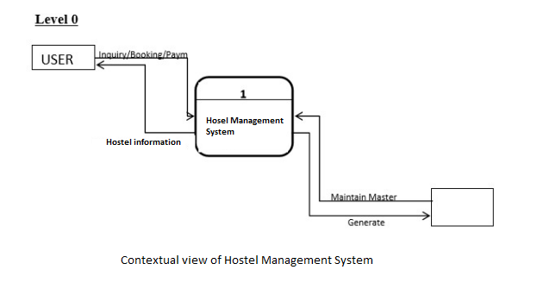

### 3.1.2 USE CASE DIAGRAM FOR USERS AND ADMIN

A use case is a description of a systems behaviour as it responds to a request that originates from outside of that system (the user). The activities in a hostel management system is shown.

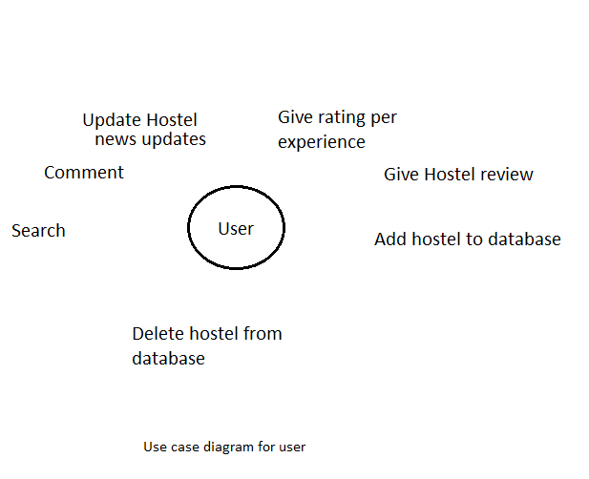

# INPUT AND OUTPUT DESIGN

The input design act as an intermediary between the information system and the user. It is made up of developing specification and procedures for data preparation and those steps are important to put but the output design is the process that involve designing important output in the form of report that should be given to the user according to the requirements. Below are some screenshots which comprises of the design of the system.

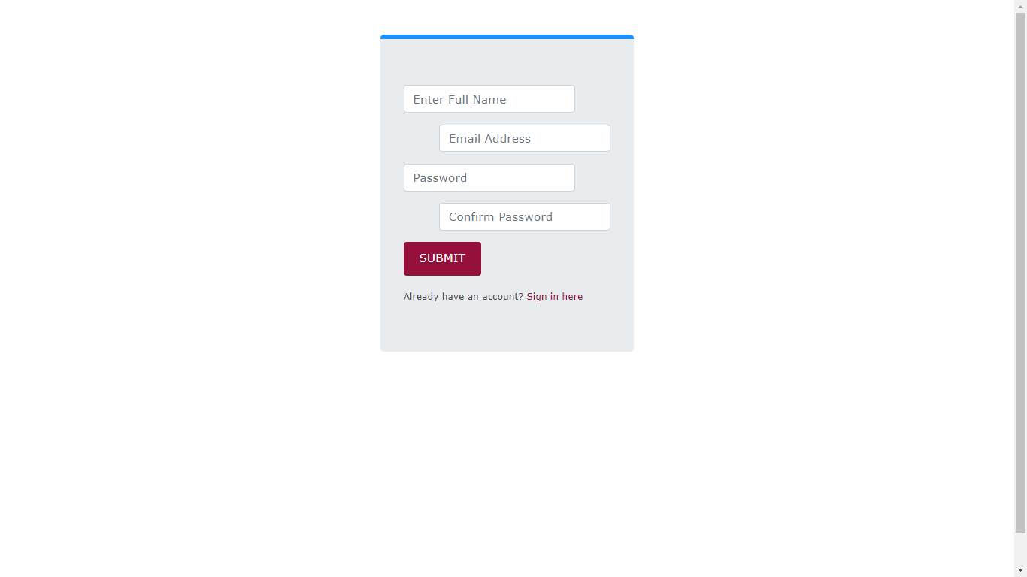

Figure 3.6 shows the registration page for any user who wants to select a hostel.

A registration form is a list of fields that a user will input data into and submit to a company or individual. There are many reasons why you would want a person to fill out a registration form. Companies use registration forms to sign up customers for subscriptions, services, or other programs or plans.Registration forms on landing pages are very important and should be [optimized](https://www.conversioner.com/blog/11-steps-for-creating-the-best-converting-registration-forms/" \t "https://www.conversioner.com/glossary/_blank)in order to encourage the users to sign up for your email list, product, subscription or service.

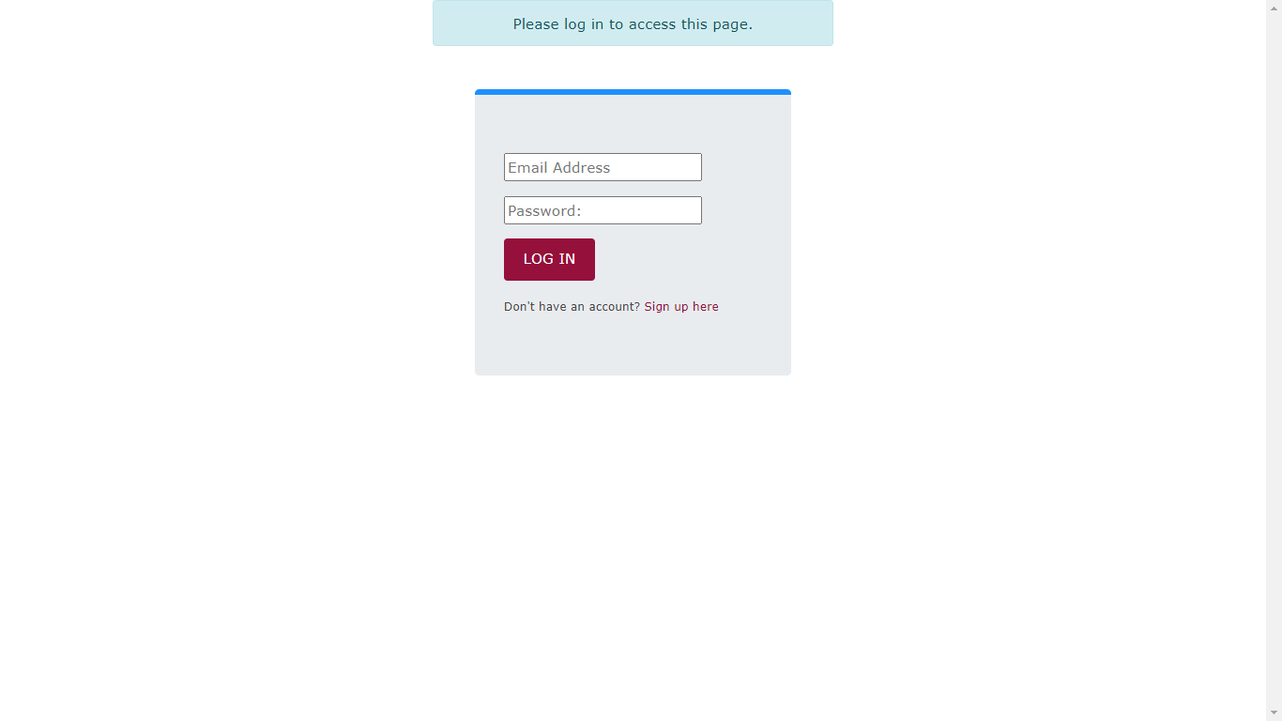

Figure 3.7 shows the login form which enables users access to their account.

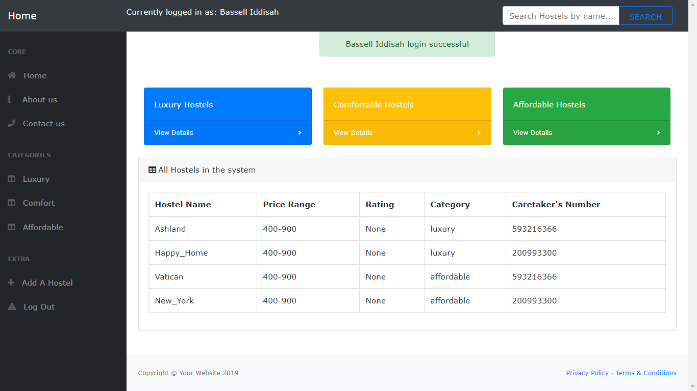

Figure 3.8 above, shows the home page of the application which has a search component to search for a hostel by name, a navigation to navigate about the app and some quick hostel details that play a part in hostel selection.

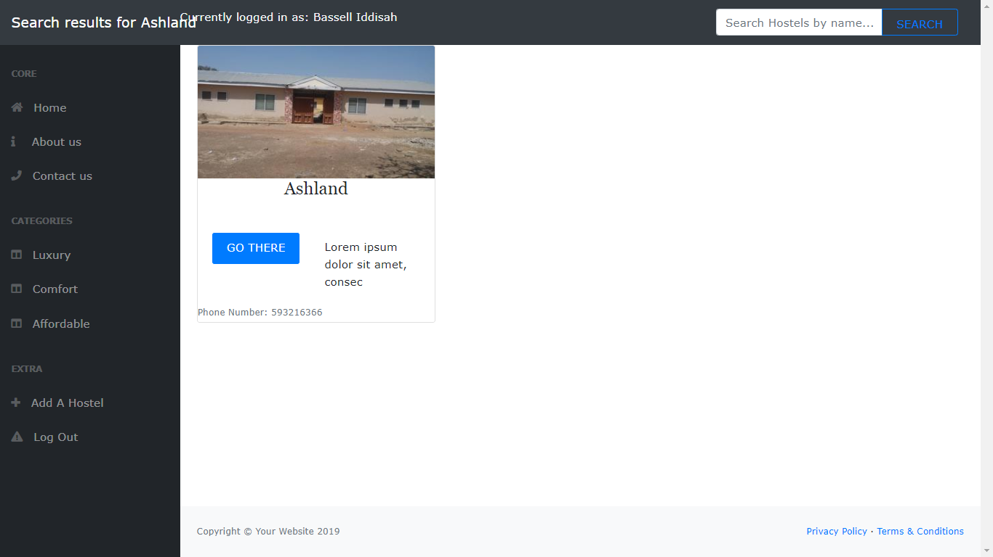

Figure 3.9 shows the search results of the keyword, ’ashland’.

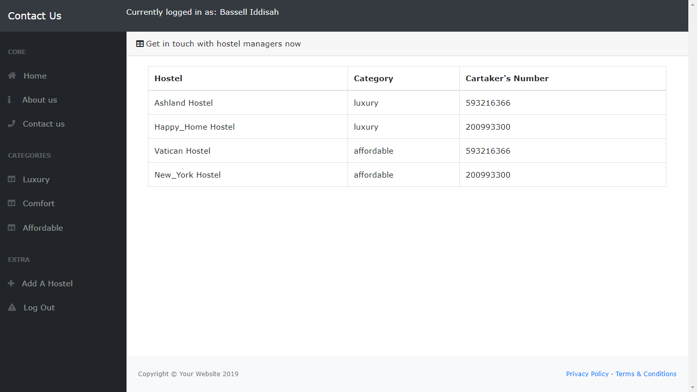

Figure 4.0 shows the ‘contact us’ which allows quick contact with hostel managers by providing their contacts, the hostels they belong to and the category of the hostel..

And last but certainly not the least, the image below gives users the option of adding a hostel to the system and an option to logout of his/her account.

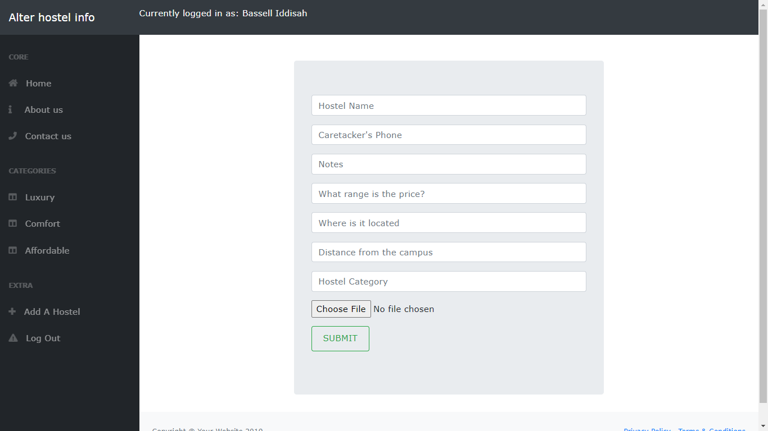

# CHAPTER FOUR

## RESULTS AND DISCUSSIONS

Students and non-students can select a hostel from the large range of available hostels on campus and off campus online and pay to the hostel landlord through mobile money transactions. Other institutions can also use the online system to aid individuals in finding and securing affordable and comfortable places to rest their heads for the coming academic year. Furthermore, the online system is expected to help ease especially the landlords and hostel caretakers who would have to engage those who wish to rent a room in their hostels on a chance that they may or may not take a room. It should also assist the townsfolk in cases where the hostel built by them may not be popular to the people and students or even trusted enough. In the long-term operation, the continues addition of hostels to the database is expected to be a platform where even travelers find affordable accommodation with environmental conditions that give them the most comfortability.

Besides that, as mentioned above, Hostel Management System is expected to develop based on the idea of the electronic age and its technological advancements. This is because similar system does not mainly exist much in Ghana but exist in most developed countries like United Kingdom and the United States.

## 4.1 LIMITATIONS O F THE STUDY

Illiteracy. This is one of the limitations of online hostel management system. Technology has become a catalyst in our daily activities. So for a customer to be able to meet his requirements, there is the need for him to at least read and write.

Internet access. The online hostel management system is an application that work within a centralised network. It need an internet connection in order to be accessed from a user’s device. So a customer should have an internet connection in other for him to be able to be satisfied.

# 4.2 SUMMARY

In summary, the project is discussed in terms of the current system operations, objectives, goals, and rationale. The author has also defined the exact reasons why this project need to be initiated that address the problem of the current system to find out what are the actual complications encountered by the business and what are the most effective requirements and methods that could be utilized to apply what method exactly needed to enhanced in current systems. This system will be developed using a waterfall methodology for a design and implementation purposes. Python is the programming language used because of its server-side processing capabilities of a micro-framework (flask) that makes data process less on the client personal computer. An implementation strategy as well as maintenance and testing strategies suitable for efficient deployment of the system.

## 4.3 RECOMMENDATIONS

Research and development are continuous. This is the same in computer and software development. However, this work is recommended for the university for development studies (UDS). It can be useful to other tertiary institutions whose processes are still manually done. Also, it will be more beneficial to both clients and hostel representatives if clients can create an account just like in social media web sites. With that, the system can record the modifications made. Other functionalities such as the e-mail for sending messages to tenants, Hostel Management with credit cards, etc. could also be integrated into the system in order to enhance user friendliness and interaction.

## CHAPTTER FIVE

# 4.5 CONCLUSION

It can be observed that computer applications are very important in every field of human endeavour. Here all the information about a customer that made a room reservation can be gotten just by clicking a button on this new system, some of the difficulties encountered with the manual system are overcome. It will also reduce the workload of the landlord and caretaker, reduce the time for making reservation by first having to ask about and find the hostel before asking which rooms are available and also increase efficiency. The application also has the ability to update records in various files with the help of the caretakers thereby making it easier to safely preserve hostel information. This project, as a whole, will give a new way in hostel management.

# REFERENCE

Micro-framework.In Wikipedia (2020, July 25).

[en.wikipedia.org/wiki/Microframework](https://en.wikipedia.org/wiki/Microframework))

Onstrategyhq, 2020,strategic planning application [online] Available at :[onstrategyhq.com/resources/what-is-a-management-system/](https://onstrategyhq.com/resources/what-is-a-management-system/)

Computer Hope, 2020, P-Definitions[online] Available at:

<https://www.computerhope.com/jargon/p/portals.htm>